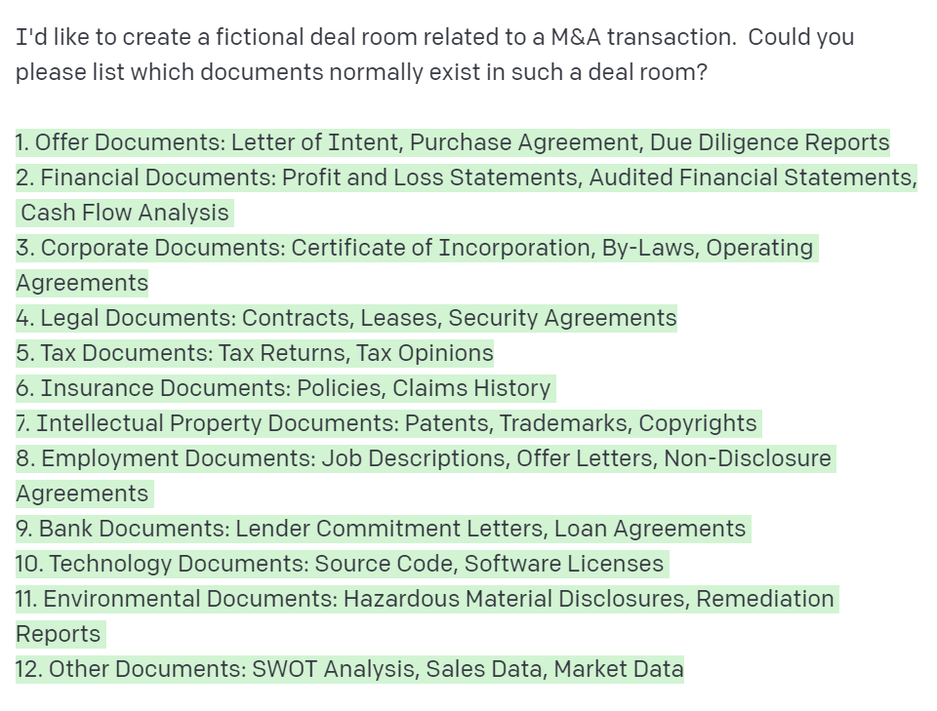Great! Now let's start by creating the employment agreements. Could you please come up with five fictional employees? 1. Diane Burns – CEO 2. Adam Moreno – Chief Financial Officer 3. Lawrence Jackson – Chief Operating Officer 4. Liz Pham – Chief Marketing Officer 5. Pete Anderson – Chief Technology Officer Can you please create an employment agreement for Diane Burns?